REPORT 2018-19

Details of campus placement during the year:

 | On campus
 | Name of Organizations Visited | Number of Students Participated | Number of Students Placed
1 | DE Shaw & Co. | 25 | 1
2 | HDFC Bank | 30 | 1
3 | BRICS Chamber of Commerce & Industry | 25 | 1
4 | Hungerbox | 25 | 2
5 | SBI | 45 | 1
6 | Andhra Bank | 45 | 1
7 | Railway Hospital | 25 | 1
8 | ICICI Bank | 25 | 7
9 | Nurtr | 25 | 2
10 | Muse Management | 25 | 1
11 | Bulbul Shop Application, Delhi | 25 | 1
12 | Parliament Office | 25 | 1
13 | MSL India Public Relations Team | 25 | 1
14 | Faze Management, Mumbai | 25 | 1
15 | Oberoi Group of Hotels | 25 | 2
16 | Shalom Public School | 15 | 1
17 | Thomson Digitals (India Today Group) | 20 | 8
18 | ZS Associates | 20 | 1
19 | Aakash Institute | 20 | 4
20 | Canara Bank | 20 | 1
21 | Gramin Bank of Haryana | 25 | 1
22 | University of Delhi |  | 1
23 | Quint | 30 | 1
24 | Government of Rajasthan | 30 | 1
25 | The Math Company | 10 | 1

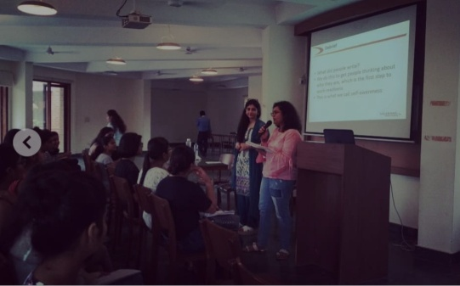
Details of the events organized during the year:
- Talk with Talerang- Internships and Resume Building (28.08.2018) (Speaker: Sveta Raina)
The session equipped students with the know-how to create a good resume to land their dream internship/job. It also threw light on the importance of going for internships.

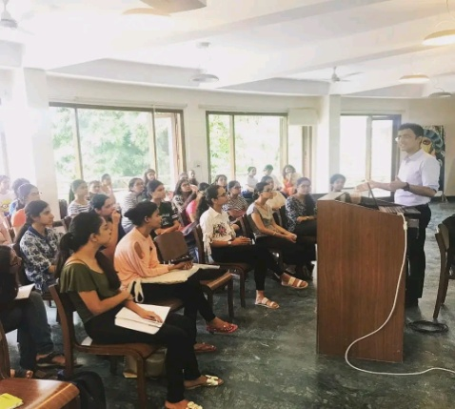
- Become Data Analytics Expert in 12 Weeks (in collaboration with The Career Developers on 07.09.2018)
The seminar gave insights about Data Analytics and Artificial Intelligence which is taking over the world and discussed the technological changes that will soon rule the world.

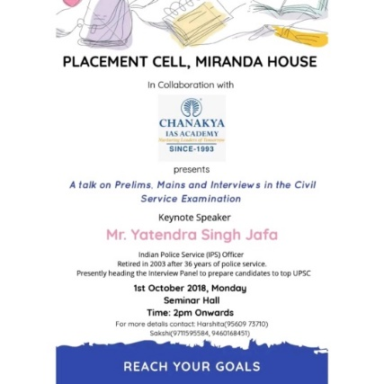
- IAS Preparation Talk in collaboration with Chanakya IAS Academy (01.10.2018)
Chanakya IAS Academy organised a fruitful session talking about the arduous IAS preparation.

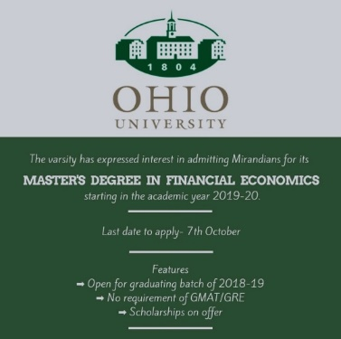
- Master's Degree in Financial Economics in collaboration with Ohio University
Ohio University conducted an insightful session and extended a golden opportunity for Mirandians by encouraging them to take up their Masters program in Financial Economics.

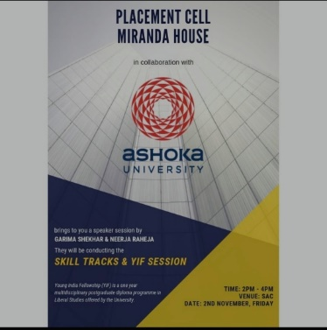
- Speaker Session on Skill Tracks and YIF in collaboration with Ashoka University on 02.11.2018 (Speakers: Garima Shekhar & Neeraj Raheja)
The session in collaboration with Ashoka University talked about the YOUNG INDIA FELLOWSHIP (YIF), the one year multidisciplinary postgraduate diploma programme in Liberal Studies offered by the University.

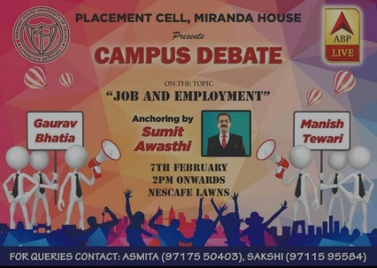
- Campus Debate on "Job and Employment" in collaboration with ABP News on 07.02.2019 (Anchor: Sumit Awasthi // Panelists: Gaurav Bhatia and Manish Tewari)
ABP News organised a campus debate on "Job and Employment" for the programme 2019 Ke Joshile!

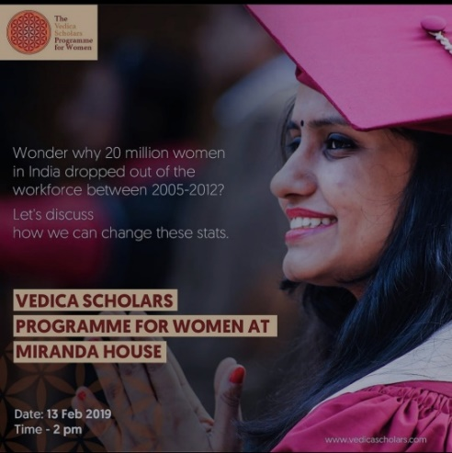
- The Vedica Scholars Program in collaboration with
Vedic Scholars (13.02.2019)
This speaker session with Vedica Scholars elaborated the The Vedica Scholars Programme for Women representation. It was an opportunity to discuss, debate and learn about these issues and how Vedica is leading the fight to reduce gender disparity in the workforce.

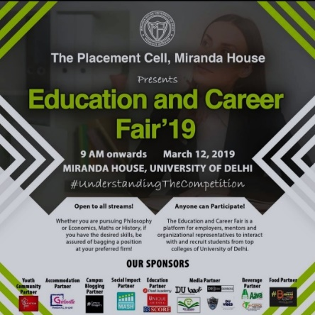
- Education and Career Fair in collaboration with Central Placement Cell, University of Delhi on 12.03.2019
The Education and Career Fair was a one-stop shop for jobs, internships and an experience with varied sponsors and even more participants.

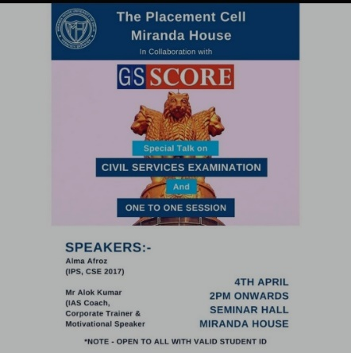
- Session on Civil Services Examination in collaboration with GS Score on 04.04.2019 (Speakers: Alma Afroz and Ashok Kumar)
The Placement Cell in association with GS Score organised an interactive session on cracking civil services examinations with the best in the field.

- Tech Leaders Fellowship in collaboration with Plaksha University on 13.04.2019
Plaksha University in collaboration with the Cell offered a One-Year Postgraduate program that focuses on Data-X coursework in AI.

